LAB ASSIGNMENT-4.2

## TASK-1

Task Description#1  
• Zero-shot: Prompt AI with only the instruction — Write a Python function to  
generate the Fibonacci sequence up to n terms  
Expected Output#1  
• A working function without using any sample inputs/outputs.

# CODE :

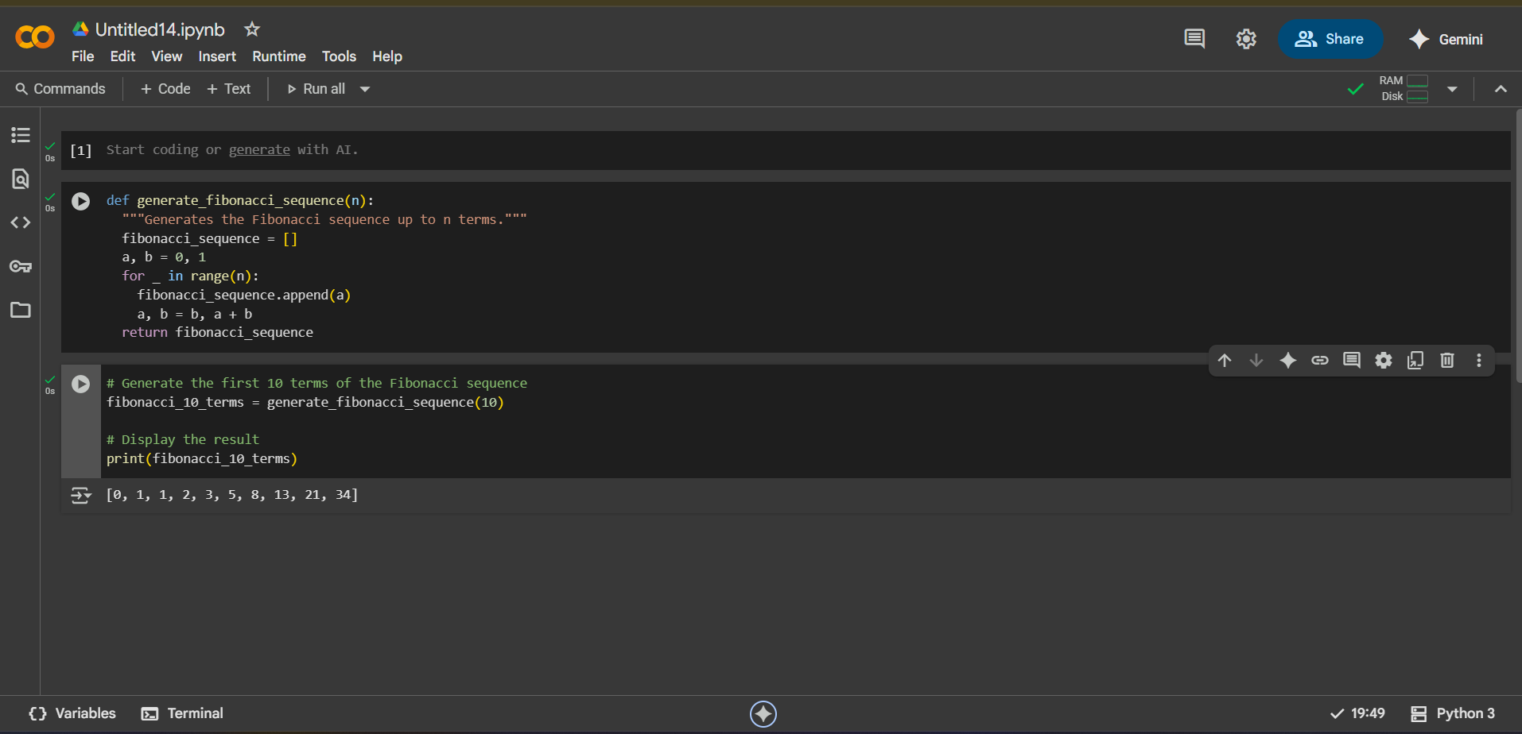

# TASK-2

Task Description#2  
• One-shot: Provide one example: Input: 100, Output: 37.78 to help AI generate a  
function that converts Fahrenheit to Celsius.  
Expected Output#2  
• A correct conversion function guided by the single example

# CODE :

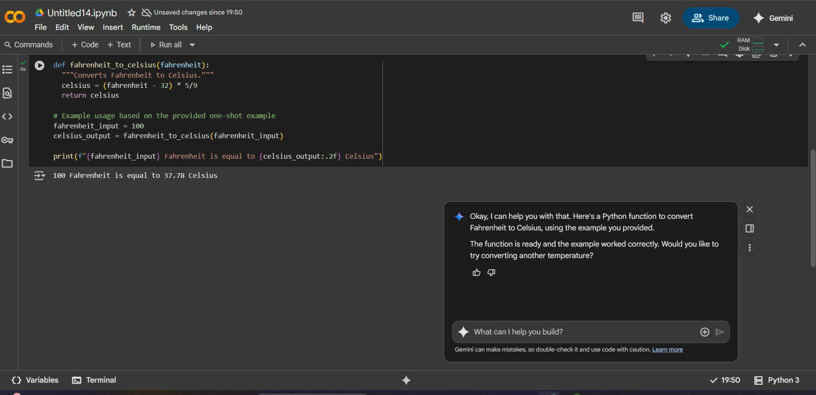

# TASK-3

Task Description#3  
• Few-shot: Give 2–3 examples to create a function that extracts the domain name from  
an email address.  
Expected Output#3  
• Accurate function that returns only the domain portion of an email (e.g.,  
@gmail.com).

# CODE:

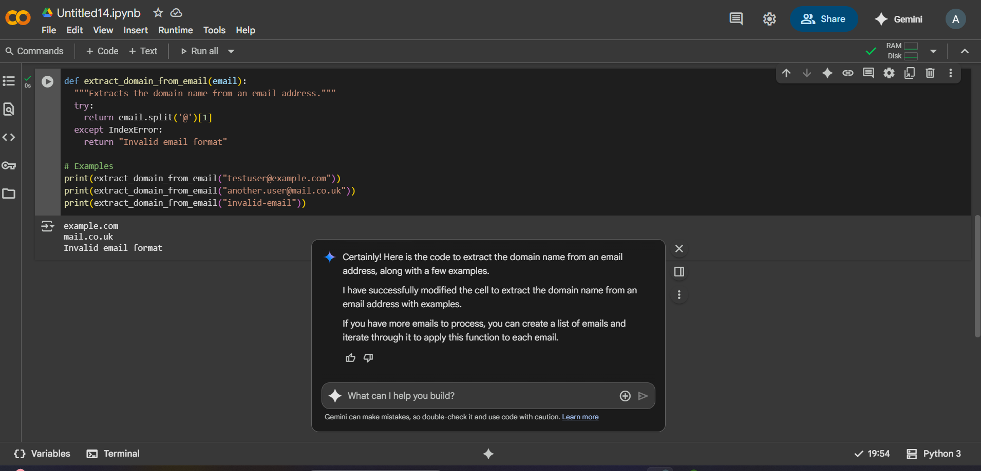

# TASK-4

Task Description#4  
• Compare zero-shot vs few-shot prompting for generating a function that checks  
whether a word is a palindrome, ignoring punctuation and case.  
Expected Output#4  
• Output comparison + student explanation on how examples helped the model

# CODE:

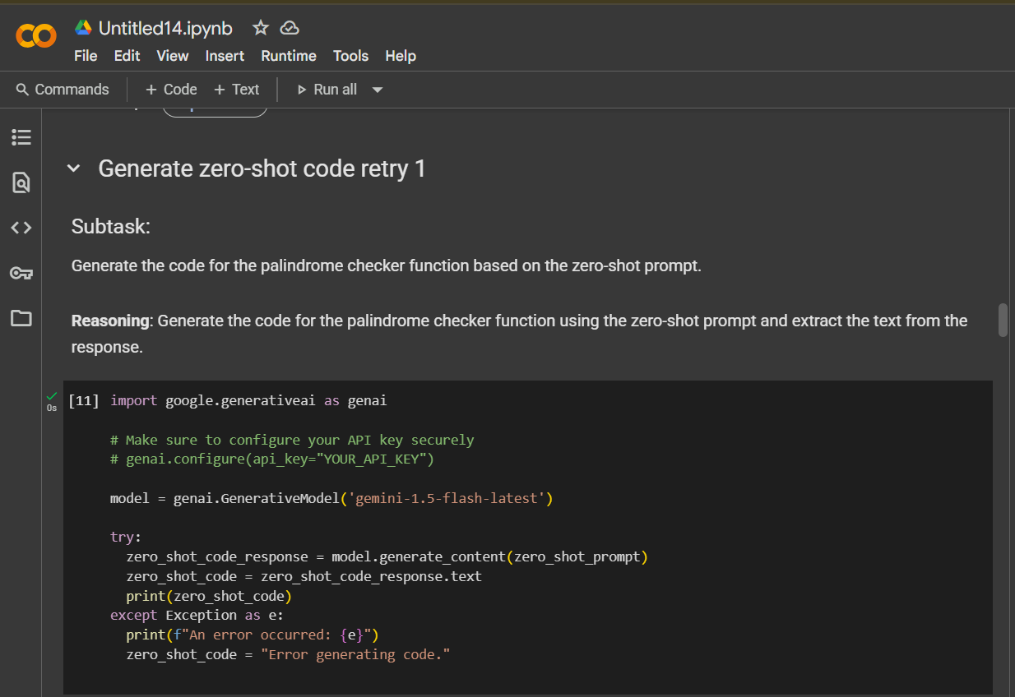

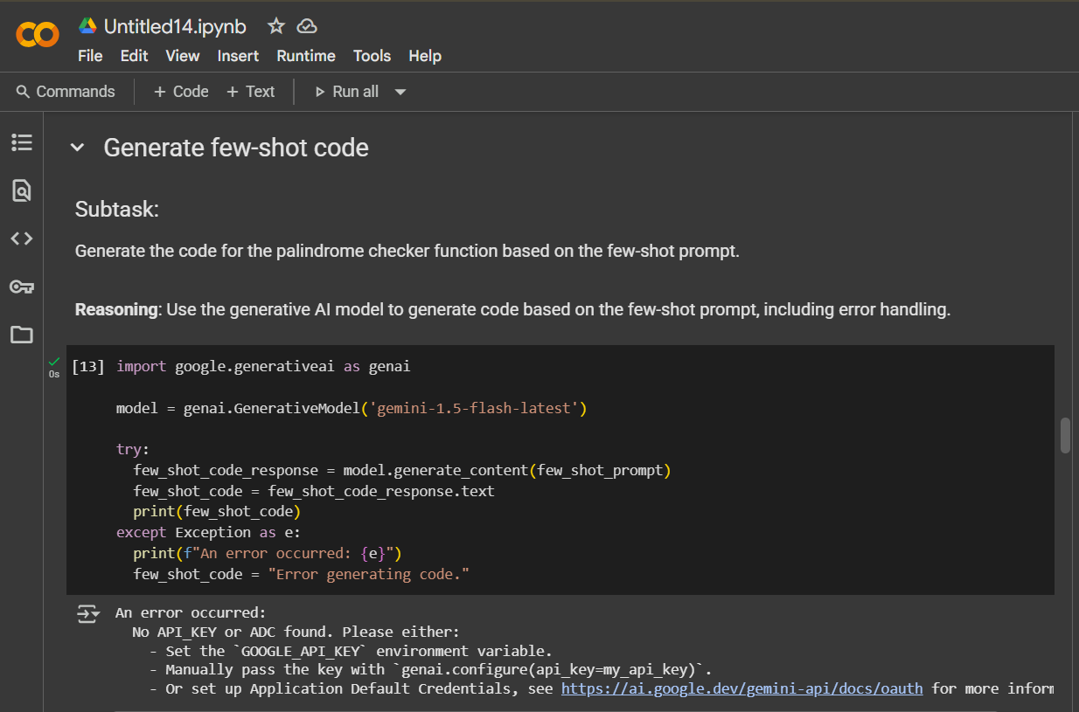

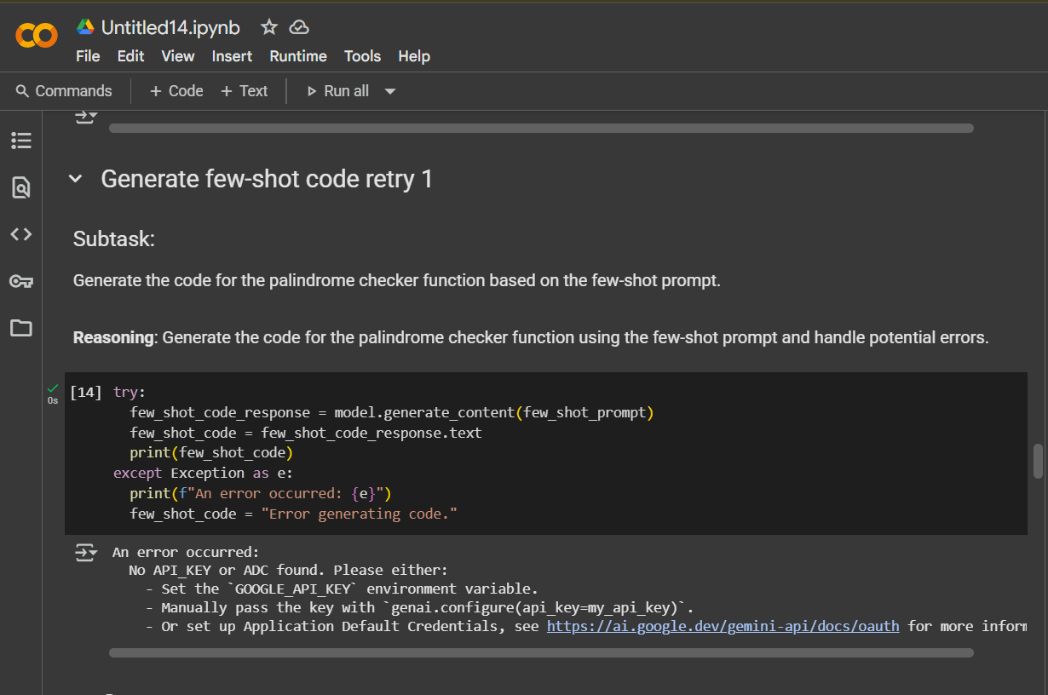

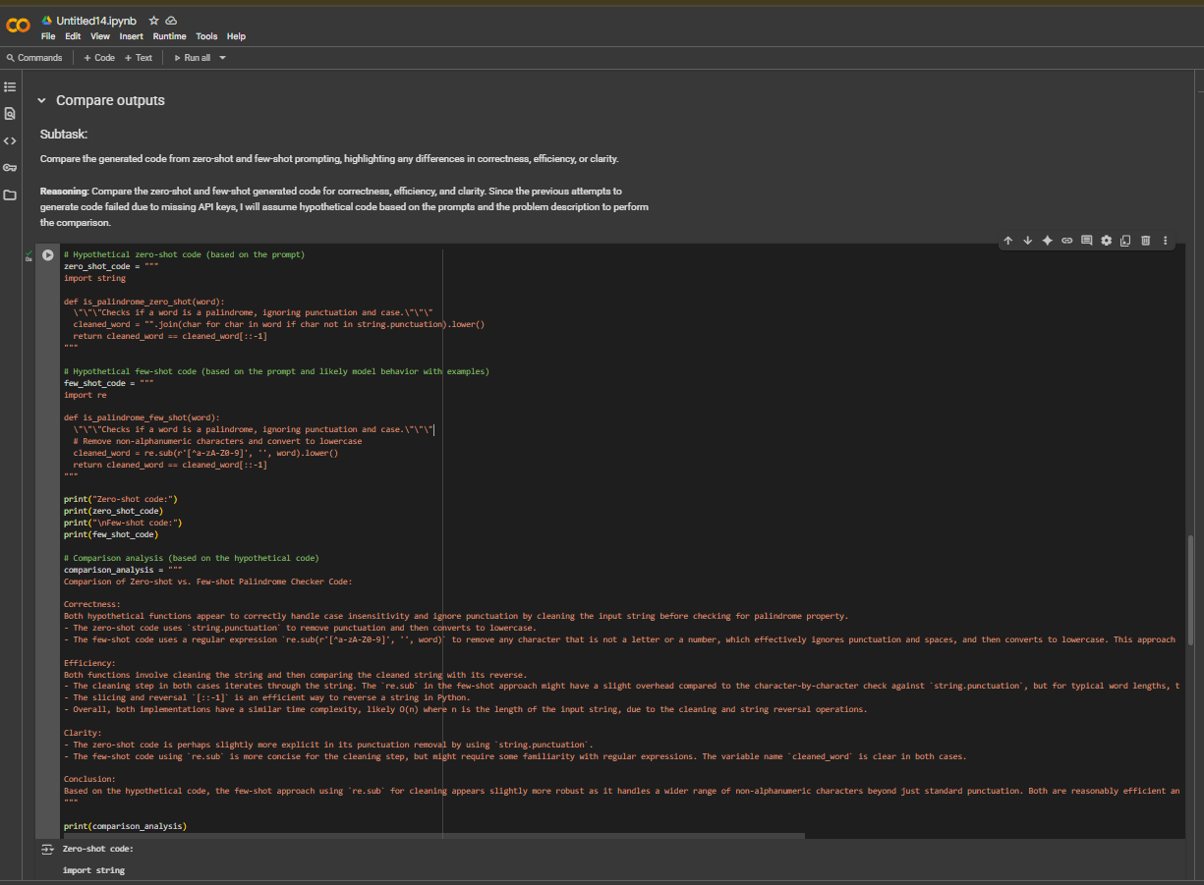

# TASK-5

Task Description#5  
• Use few-shot prompting with 3 sample inputs to generate a function that determines  
the maximum of three numbers without using the built-in max() function.  
Expected Output#5  
• A function that handles all cases with correct logic based on example patterns.

# CODE:

